The General Collections Conservation unit of Indiana University Library's E. Lingle Craig Preservation Lab treats an average of 13,000 items per year. Treatment may be as simple as reinserting single pages that have come loose to completely rebuilding and repairing a 300-year-old monograph. However, several times each year the Lab is sent items in a red biohazard bag; these require special handling or disposal. Often the contents of these bags are books thought to be hosting active mold growth, and the Craig Lab staff is asked to assess the item and decide whether it can be saved or needs to be withdrawn. This, Tale of Two Books, is an overview of the steps we follow when a monograph shows up that has mold and will give you an idea of the process we use to remediate this problem when the item is important enough to warrant the time and effort.
Usually the circulation desk staff will notify the Lab when a book that they suspect has mold is being sent to the Lab so we know to be looking for it. However, sometimes we do not know what the problem might be until we open the bag. Fortunately, red biohazard bags are hard to miss, so when one shows up we know to take special care in handling its contents. While we are not overly concerned with the supposed toxicity of mold, neither are we careless with it. Mold can trigger unpleasant allergy-like reactions and/or contaminate workspaces if its presence is extensive. Also, some books may have other, potentially more hazardous issues. Therefore, the contents of these bags are dealt with either in a controlled environment such as an exhaust hood or outdoors where there is unlimited air exchange.
About 25% of the time, the problem that was sent to us as mold turns out to be either just dirt or ink that has run, or a combination of the two. We appreciate this as erring on the side of caution. A more casual attitude on the sender's part could result in our dealing with a major mold infestation in a collection space, so we do not mind receiving an occasional "false alarm" book.

Two Books
The two books in this first photo were sent to us in a biohazard bag earlier this summer. The Wells Library staff thought that both might have a mold problem. Both showed significant discoloration along the top edges, but only one had any evidence of mold, on the bottom edge. We believe that the dark staining on the top edges is the result of smoke from a fire that happened a few decades ago in the older library on the Bloomington campus. The smoke damage had been treated as effectively as possible using a dry cleaning procedure, and it had no odor. Thus, the tale ends for the book on the left in the image; it needed no further treatment.
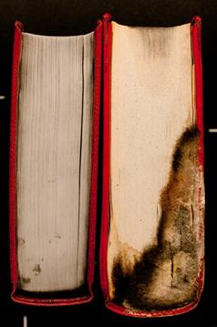
The Northeast Document Conservation Center has a good overview on salvaging moldy books and paper (Northeast Document Conservation Center: Preservation Leaflets 3.8 Emergency salvage of moldy books and paper http://www.nedcc.org/resources accessed 6 September 2011). The NEDCC site says that there are over 100,000 types of fungi (e.g., mold and mildew) which make identifying the specific type of mold, when that matters, difficult at best for the lay person. The NEDCC notes that "molds excrete enzymes that allow them to digest organic materials such as paper and book bindings, altering and weakening those materials. In addition, many molds contain colored substances that can stain paper, cloth, or leather." So, if you have a book that has mold, what steps should you take? That is what the remainder of this post will discuss.

Step One: does the book warrant the effort
Decide whether the book is one that it is sensible to spend the time and money on to salvage. It may be that a replacement is easily available and at a cost that does not warrant the effort it would take to remove the mold, or the item may be one that is no longer important to your collection, or you might have other copies of the same item and do not need the one that has the mold problem.
The book treated here suffered severe mold infestation. While it was treatable doing so would have required cleaning over two hundred pages. In the case of this particular book, the amount of time it would have taken to thoroughly clean and repair it would have far exceeded the cost of replacing it, so we made the decision to have it withdrawn. However, it provides a good demonstration opportunity. Fortunately, most books that we receive that have a mold problem come to us in a lesser state of infestation, so the treatment is much less extensive and time consuming.

Mold Facts
Mold remediation is a broad, often misunderstood, topic; conflicting information on the subject abounds. It is beyond the scope of this article to discuss mold remediation comprehensively. However, understanding a few basic concepts will go a long way toward your ability to deal with mold effectively. First are a few facts about mold itself. Mold is a variety of fungus. Fungi have some unique characteristics. Some taxonomists have assigned mold fungi their own kingdom, separate from plants and animals. From the practical standpoint, mold behaves a lot more like plants than like animals, and it is perhaps helpful to think of mold in this way. Mold produces "seeds" (spores), and these sprout as soon as they find "soil" (wet materials.) The sprouts then mature and make spores of their own, lots of them and really fast. These in turn sprout and the process continues so that in a very short period of time the result is a thriving colony of mold.
A single mold spore is unimaginably tiny (as small as 2-3 microns) and virtually void of water and so it is very nearly weightless. One statistic that illustrates this is that mold spores are said to fall at a rate of three feet per hour in still air (Applied Microbial Remediation, IICRC Certification class held on October 25-28, 2004, Greenfield, IN taught by Mike and Rachel Adams). Furthermore, some varieties of mold are customarily found in higher concentrations indoors than outdoors. Mold spores are almost always in the air both indoors and outside. (Florian, Mary-Lou E., Fungal Facts (Archtype Publications, 2002: 102) It is practically impossible to eliminate mold absolutely from a general environment. Thus, the goal of remediation is not to eliminate mold but to locally eliminate conditions supporting mold growth, within a given physical parameter. This parameter might be the entire structure and contents of a building or, as in our example, a single item.
Active (living) mold is somewhat slimy to the touch and will smear when you rub something (for example, your finger – in a protective glove, of course) across it. Inactive (dead) mold is dry and powdery. From the purely physical standpoint, this makes sense. Whether mold is active or inactive depends on one simple factor: the presence or absence of water. Nearly any material will support mold growth, but only if water is present. Remove the water and the mold becomes inactive.
The part of the mold that needs to be made inactive is the part that compares to the body or stems and leaves of plants. Even though the mold has been rendered inactive, it is just as reproductively viable as active mold should water be re-introduced. The dry, dusty mass of the inactive mold includes a huge number of "hibernating" spores. Mold spores are difficult to effectively kill. So "killing the mold" is not an objective of remediation. Rather, the spores must be removed.

Step Two: Removing mold spores
Washable surfaces should be cleaned with detergent and water only. No biocides or other chemicals need to be used because they are no more (and perhaps even less) effective than detergent and water. When the host material is absorbent and not meant to be washable (like paper), determining the state of the mold comes first. If the mold is active, full-immersion washing is effective, but it can be quite time- and space-consuming. For more than a small volume of loose documents, this is often not practical; it is often even less practical for books. Generally speaking, no attempt should be made to remove active mold from paper by means other than washing, as it will only smear it and increase the amount of staining. The staining caused by mold is nearly always permanent.
If the decision is made to attempt removal of the mold from a book, and it is determined that the mold is still active, the first step of the treatment process is to render the mold inactive. As mentioned previously, this entails removing its water source. The least expensive way to do this is to take the book outdoors, stand it on edge in direct sunlight, and let nature dry the mold. This method is weather-dependent, of course. If it is necessary to wait for good outdoor drying conditions, the book can be wrapped in a plastic bag and placed in a freezer. This is primarily just to buy time. Freezing will render most of the active mold inactive, as freezing its water source naturally makes it less available. However, freezing does nothing harmful to the spores, and the paper will still need to be dried once removed from the freezer.
How long it will take to dry will be dependent on how wet the book is when you receive it and how extensive the mold growth is. We have learned that most items that get wet will dry just fine once the source of the water is removed. The source of the water that encouraged the mold to grow on our example book is not known. Our best guess is that the shelf where it was housed had a low spot and water from an unknown source puddled under this book, and the paper and binding absorbed the moisture.
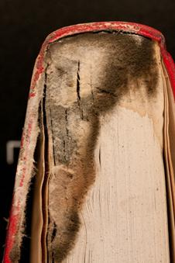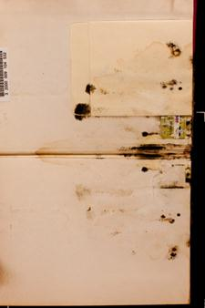
Regardless of the moisture source, the amount of mold in this particular book was extensive. Fortunately, it was confined to this one item and did not spread to the surrounding parts of the collections.

Step Three: Specific Treatment Steps
By the time we received this book it had already absorbed all of the water and was in the process of drying out. We allowed it to continue drying until we were satisfied that the mold was inactive.
There are several options for removing inactive mold. The one described below is the least expensive one that we know of and is easy to perform. If your library owns a HEPA filter vacuum cleaner, it can be used to remove the large, easily accessible growths. The following steps should not be performed in an area that is enclosed, where space and/or contents contamination are concerns. The best place to perform the necessary steps is outdoors provided conditions are suitable.
The materials you will need include:
Examination gloves. Those made of Nitrile are preferable to latex since the latter causes an adverse reaction for some people.
N95 mask or cartridge respirator. If the latter, medical clearance and fit testing are required. (Applied Structural Drying, IICRC Certification class held at Hydrolab, Noblesvillle, IN on June 2-4, 2004 taught by Kurt Bolden and Bill Yeadon)
A paint brush
An apron or protective coveralls
An eraser sponge (As in this exercise, we use an Absorene Dirt Eraser for many projects involving the dry cleaning of books and paper.)
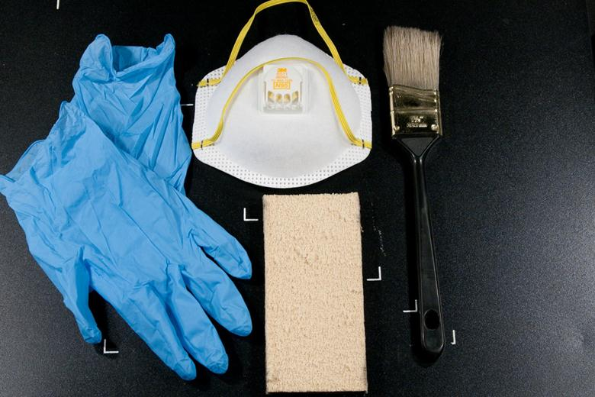
Step One: Put on the gloves, apron and mask and carry the moldy item, brush and sponge to the location where you will be working on it.
Step Two: Use the brush to remove the most obvious mold on the exterior of the item if there is mold present there. Then open the book and begin to examine the interior for signs of additional mold growth.
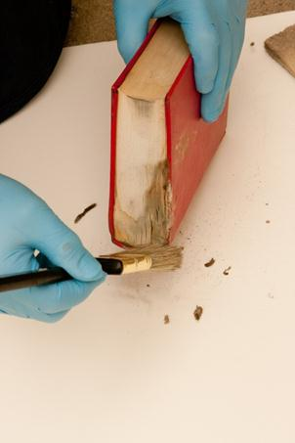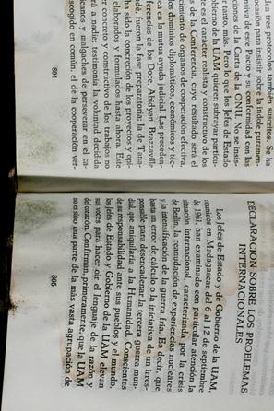
Step Three: Use the eraser to "erase" the mold from the pages of the book, brushing away from the center of the book. Use the brush to remove the mold from the center gutter area. Repeat this step on every page where mold is present. For the book used in this example, over 200 pages needed to be cleaned. This is the part of the treatment we did not do in full, but one example is shown below. Otherwise, all of the steps are represented in this article as they would be performed if the book had been one that had to be saved. The point here is that inactive mold can usually be removed cleanly from paper and often leaves behind little or no evidence that it was ever there.
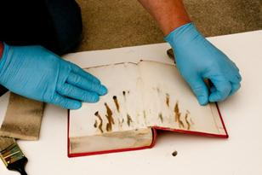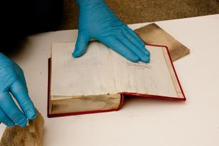
Before erasure After erasure
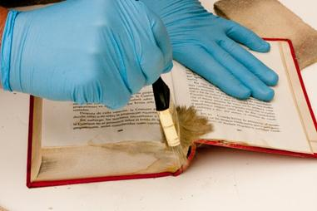
Using brush to remove mold from the gutter following the use of the eraser
Step Four: If the mold infestation is severe, as in our example, it is necessary to disbind the book and check the parts of it that are normally hidden from view. (See next image.) Note that if you do not have the knowledge, skills or means to re-bind the book following this step, then obviously you will need to call in someone else to do this work. If you have access to the tools and materials and would like to have a look at the procedure, a detailed guide can be seen by clicking on "Recase" or "New Case" (depending on whether or not the original case is usable) in the Preservation Manual on the E. Lingle Craig Preservation Lab's web site: http://www.indiana.edu/~libpres/manual/mantoc.html
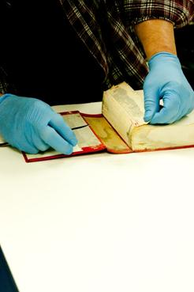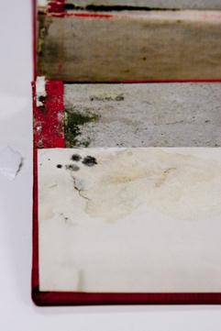
Due to the extensive amount of mold evident on this book, we decided to look in less accessible places that seemed likely to harbor mold growth. As is often to be found, the hollow of the spine was one location that showed high concentrations.
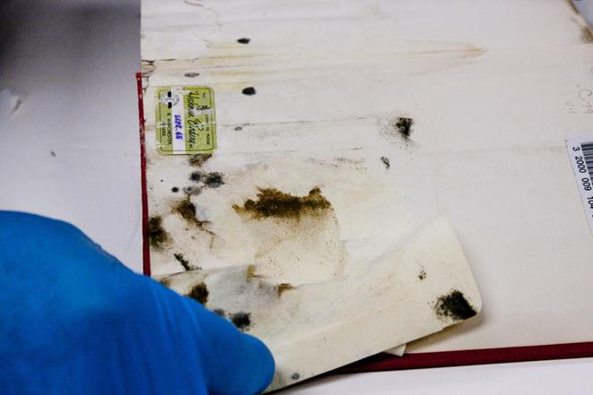
Another was under the circulation pocket.
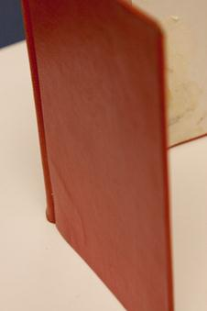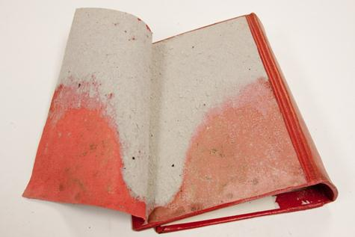
While working on the cover, Garry Harrison noticed a slight bulge in the cover material in the lower corner that he suspected might also be harboring mold growth. The bulge and the problem he discovered are shown above.
Step Five: Since the cover was off the book and unusable we took the opportunity to trim the smoke tinted end and return it to a more natural state, using a hydraulic guillotine paper cutter. Harrison then constructed a new case for the book. The following image shows completed item.
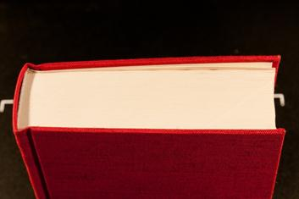
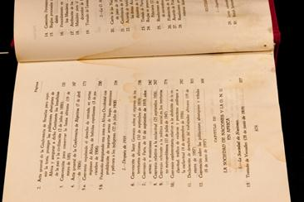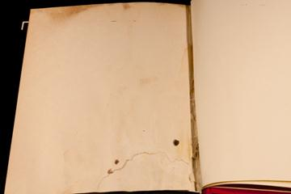
The interior of the book shows staining from at least three different sources. The stain in the lower left photo is a tide line left by the water. In the lower right photo, the stain at the top is from smoke, and the spots are dye produced by the mold. These pose no threat of re-infestation, but staining of any type always presents the question of whether or not the item is visually acceptable for return to the collection. Sometimes photocopied replacements are a solution for text-bearing pages, and blank endpapers can simply be removed.
In summary, mold-infested books call for decisions as to whether or not the book should be treated and, if so, how to treat it. Our example was an extensively infested book. To warrant the effort necessary for effective treatment, it would have to be valuable and/or difficult to replace. On the other hand, many less severely afflicted books can be quickly and easily restored via the dry removal methods described.

